Important Information for Participation in Virtual Sessions
October 22-23, 2025
Virtual attendees can choose from 12 live-streamed sessions during these 2 days. To sign up for or access the sessions you would like to attend, visit: https://conference.cadreworks.org/ and log in to your account.
Prior to the day of the event, log into your account and navigate to the sessions you would like to attend. If you experience any issues with logging into your account, please contact Kelly (krauscher@directionservice.org) or Noella (nbernal@directionservice.org).
Accessing Sessions on Your Agenda
- Pacific Daylight Time (PDT) is used throughout the Symposium Schedule. Please plan accordingly to ensure that you don’t miss a session due to a time zone conversion issue. If you added sessions to your calendar directly from the Session Description pages, the time zone conversion may not have automatically occurred or occurred incorrectly due to system/software updates outside of our control. Please check your calendars.
- CADRE will use Zoom technology for all virtual sessions.
- To access each of your sessions on the day of the event:
  - Log in to your Symposium Account. Stay logged in for the duration of each day of the event.
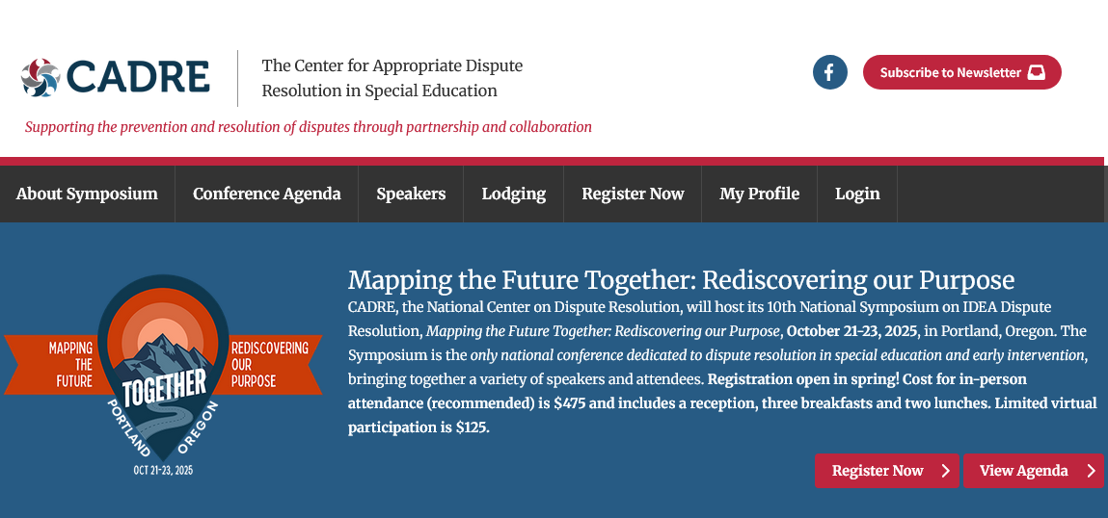
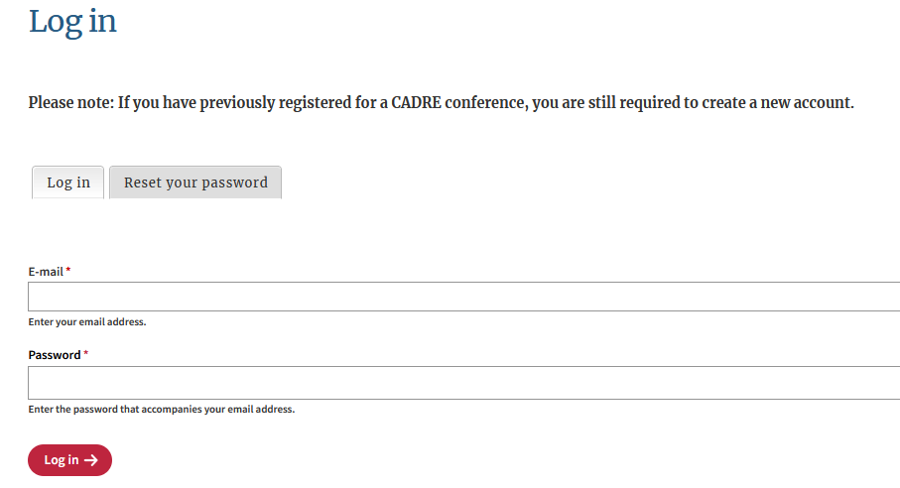
  - Select My Agenda.

- If you did not select sessions, you may access sessions in the Conference Agenda section of the website.
  - Click on the appropriate Session Title on your Agenda to access the Session Description page.
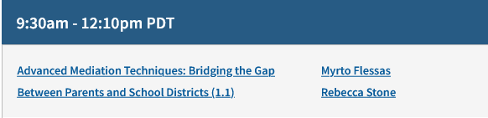

  - The Session Description page will have the Zoom link. If you wish to download session materials, do so from this page.
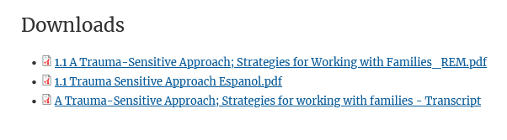
  - Click on the Access via Zoom link to enter the webinar room. Each session has a different Zoom link. Be sure to use the correct link. For more information on joining sessions via Zoom, visit: https://support.zoom.us/hc/en-us/articles/201362193-How-Do-I-Join-A-Meeting-.
Symposium Virtual Sessions and Zoom
- Participants will be in a virtual waiting room until the session begins. If you join a session already in progress, the host will admit you as soon as possible.
- All participants are muted upon entry.
- Virtual participants will not be able to interact with presenters or in-person participants.
- Closed captioning will be available.
Technolgy Tips
- Plug in your computer to an outlet to prevent the battery from dying during your event.
- Best practice would be to plug your computer directly into your router with an ethernet cable, but a good WiFi connection can work if that is not possible. If working from a home setting, make sure no one else is using your internet connection for the duration of the call.
- A good practice is to reboot your computer about an hour before your event.
- If you normally use a Virtual Private Network (VPN), it is best to turn it off.
- Close any programs not needed while in a video session.

Recordings and Materials
- Recordings and materials for all 12 virtual sessions will be made available following the event. Registrants will receive notification when these recordings are available, as well as information on how to access them.

