Accessing Your Agenda, Session Materials, and Room Locations

on the CADRE Website
October 21-23, 2025
Prior to the day of the event, log into your conference account by visiting https://conference.cadreworks.org/. Stay logged in for the duration of each day of the event. If you experience any issues with logging into your account, please contact Kelly (krauscher@directionservice.org) or Noella (nbernal@directionservice.org).
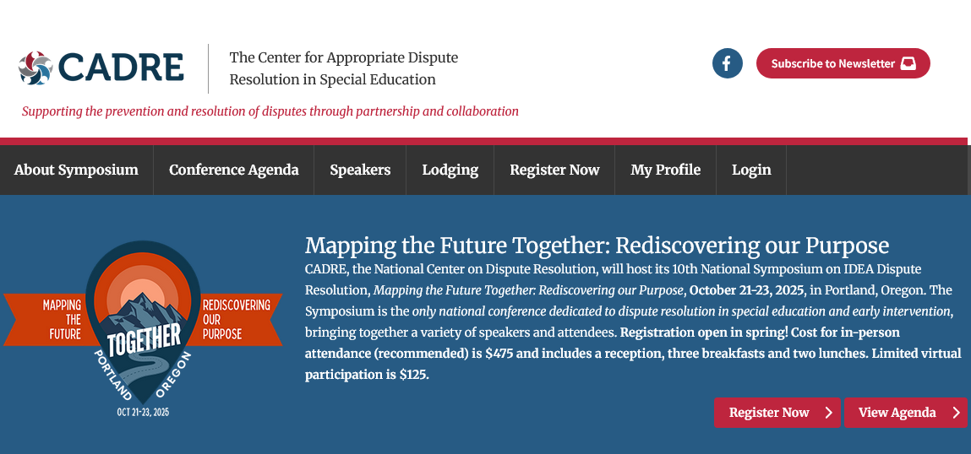

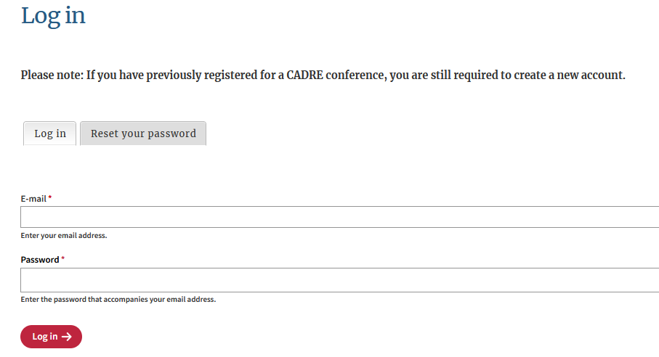

My Agenda
- If you signed up for sessions, you can view your agenda on the conference website in the My Agenda view:


  - If you did not select sessions, you may view session options in the Conference Agenda section of the website.

  - Click on the appropriate Session Title on the Conference Agenda or My Agenda to view the Session Description.

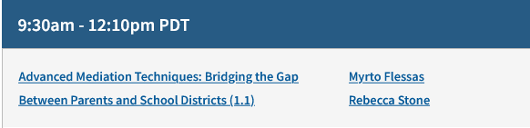

  - The Session Description and My Agenda pages have the session location (room).
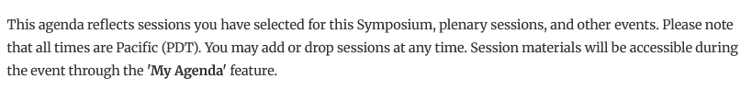
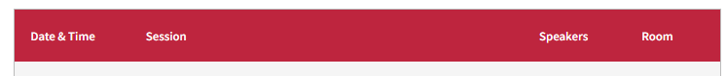

  - If you wish to download or access session materials, do so from this Session Desciription page.
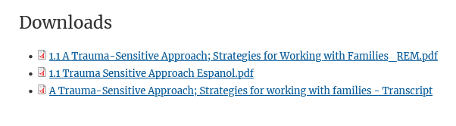

- If you wish to add sessions to My Agenda, do so from the Session Description page or Conference Agenda. Only one session per breakout period can be added to My Agenda.

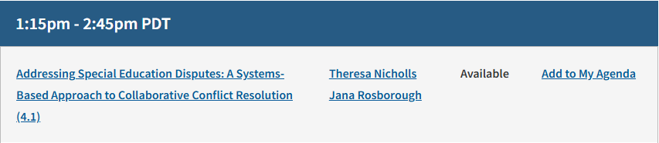

- If you wish to change sessions in My Agenda, do so from the Session Description page or Conference Agenda. Remove the session you no longer wish to attend, by selecting Remove from My Agenda before adding the session you now would like to attend.

