Important Information for Participants

CADRE, the Pennsylvania Office of Dispute Resolution, and the Oklahoma Special Education Resolution Center are hosting a virtual Professional Development for Hearing Officers event on February 9-10, 2026. Zoom will host all of the sessions through their platform and address any technical difficulties that may arise. Important information for participants is below:
Registration
Registration is limited to Hearing Officers, Administrative Law Judges overseeing IDEA, Second Tier Review Officers, SEA DR Coordinators, presenters, and event organizers. Registration closes January 31st, 2026.
Accessing Event Sessions
- To access sessions, session materials and Zoom links via the website:
  - Log into your Professional Development for Hearing Officers Account. You may be prompted to re-enter some identifying information. Stay logged in for the duration of each day of the event.
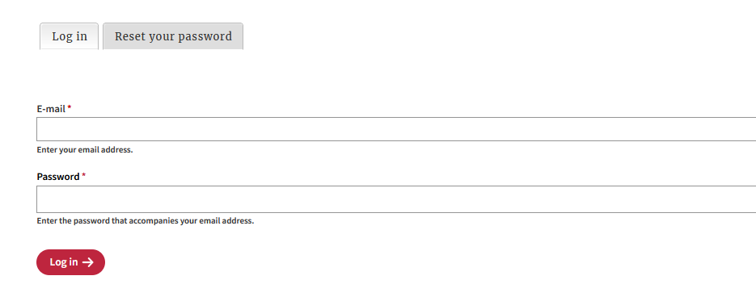
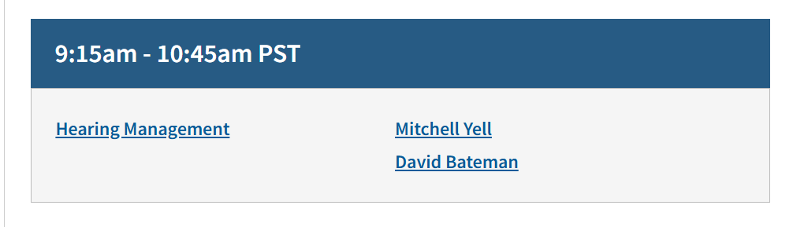
  - Click on the appropriate Session Title from the Agenda page:
  - The Session Description page will have the Zoom link. If you wish to download session materials, do so from this page.
  - Click on the Zoom link to enter the meeting room. With the exception of the Kickoff and first session of each day, all sessions have a different Zoom link. Be sure to use the correct link. Note: the agenda on the website is in PACIFIC Standard Time.
- For more information on joining sessions via Zoom, visit: https://support.zoom.us/hc/en-us/articles/201362193-How-Do-I-Join-A-Meeting-.

Adding sessions to your calendar:
- PACIFIC Standard Time (PST) is used throughout the Agenda on the website. You can add each session directly to your calendar from the event website.

  - Select the session(s) you wish to attend by clicking on the session title from the Agenda page:

  - Click on the appropriate ‘Add to Calendar’ link below the description. Please be sure that the timezone conversion has worked properly with your calendar:

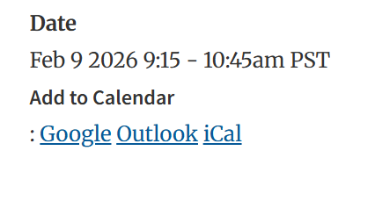

Event Sessions and Zoom
- Participants will be in a virtual waiting room until the session begins.
- Presenter(s) will provide participant instructions (e.g., raise hand, respond to polls, type in chat).
  - For information about participant controls in Zoom, visit: https://support.zoom.us/hc/en-us/articles/200941109-Attendee-controls-in-a-meeting
  - All participants are muted upon entry. If you do unmute to speak to the group, speak clearly and avoid speaking over other participants. This helps make the experience as linguistically accessible as possible.
- Presenters, staff, and Zoom host will monitor chat boxes and attend to questions as soon as possible.
- Sessions will end promptly so that we can prepare for the next session.
Technology Tips
- Plug in your computer to an outlet to prevent the battery from dying during your event.
- Best practice would be to plug your computer directly into your router with an ethernet cable, but a good WiFi connection can work if that is not possible. If working from a home setting, make sure no one else is using your internet connection for the duration of the call.
- A good practice is to reboot your computer about an hour before your event.
- If you normally use a Virtual Private Network (VPN), it is best to turn it off.
- Close any programs not needed while in a video session.
- Turn off video camera if internet connection is poor.

