Collaboration Styles
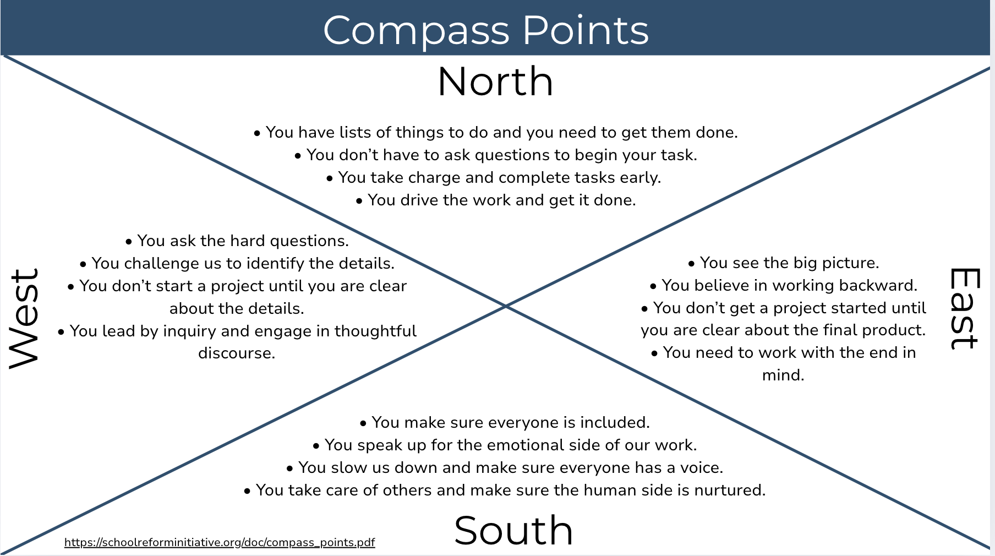

What are the strengths of your collaboration style? | What are the limitations of your collaboration style?

Case Study #1
What did Ms. Monroe do well? | Where do you see missed opportunities to make the meeting more collaborative?

Conditions for Collaborative IEP Meetings
Use the space below to capture the strategies you might use to create the conditions for collaborative IEP meetings.
Create Clear Expectations

Role Example
Use the space below to draft a description of IEP meeting roles.
Role | Description
LEA Representative
Special Education Teacher
General Education Teacher
School Psychologist
Parent
Occupational Therapist
Physical Therapist
Advocate
Student
Ensure Shared Understanding

Active Listening Techniques
Use the space below to define and provide examples of each active listening technique.
Technique | Definition | Example
Non Verbal Cues
Paraphrase
Open-Ended Questions
Reflect
Provide Accountability and Transparency

Case Study #2
Identify the strategies Ms. Brewer implemented to:
- Communicate clear expectations
- Ensure shared understanding
- Provide accountability and transparency
Communicate Clear Expectations | Ensure Shared Understanding | Provide Accountability and Transparency

Session Feedback Survey | Participant Resources
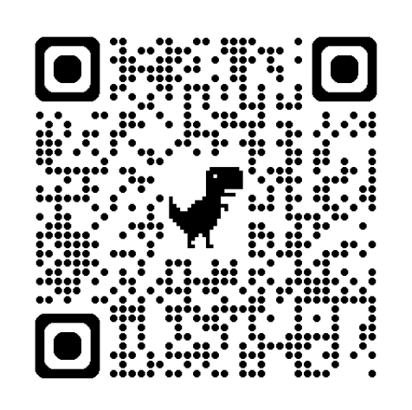  http://bit.ly/3GLdY6Y | 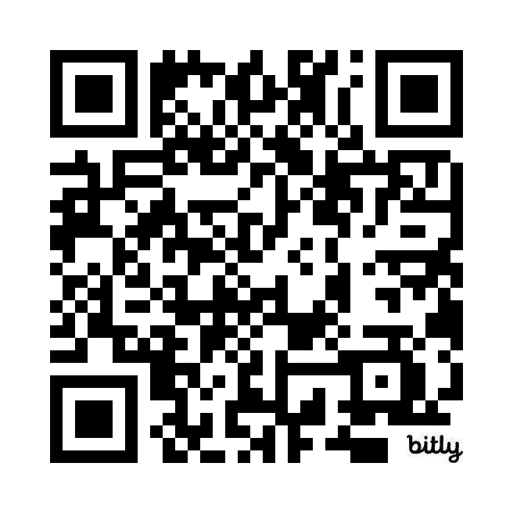  https://bit.ly/3Z9FUHZ
Notes:

Team Action Planning Activity
Use the space below to capture the next steps that your team identifies.
What | Who | By When | Date Complete

