Guidelines for a Facilitated Special Education Meeting

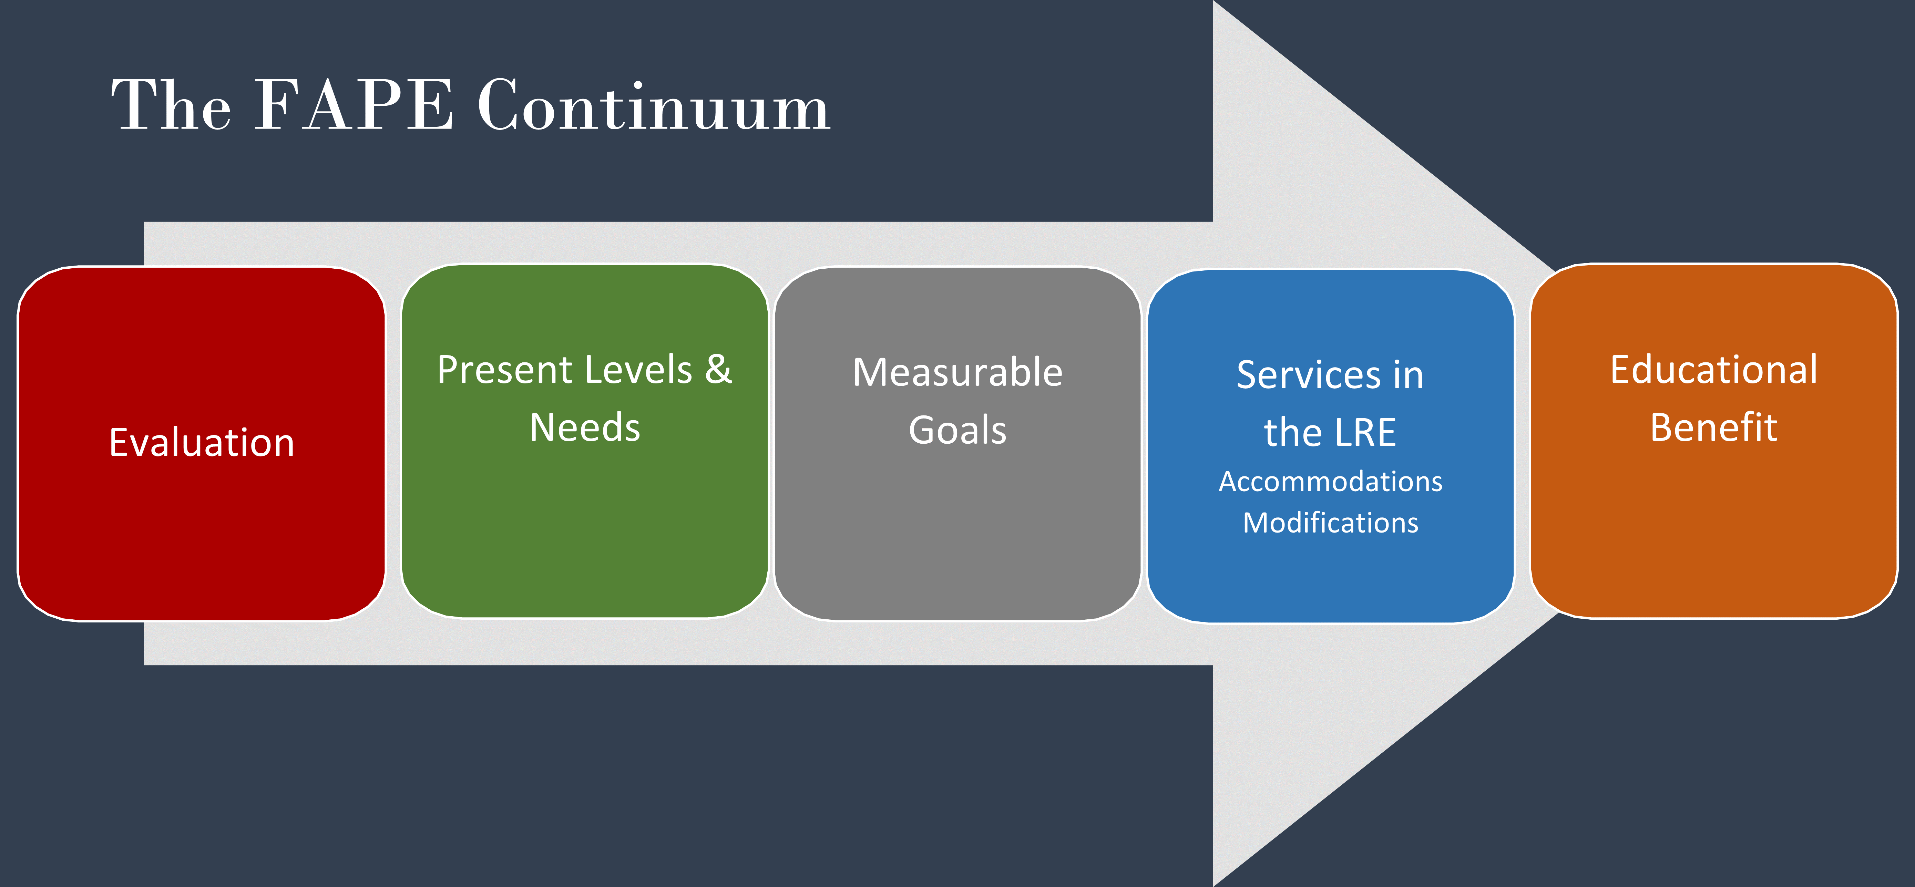

Setting the Stage for Collaboration:

* Be student-focused
* Assume positive intent of all team members - Everyone is here with the child in mind.
* Respect and listen to all perspectives - Everyone here has a role and a perspective for creating this plan of support.
* Be solution-oriented and contribute to problem solving.

Facilitated Meeting Guidelines:

* Facilitator will begin meeting by asking all participants to introduce themselves, the role they have on the team.
* Any use of recording devices will be announced at the beginning of meeting and paused or turned off during breaks and at the conclusion for the meeting.
* If capabilities exist, agenda will be displayed/distributed during the meeting. Any adjustments may be made during the meeting.
* All documents will be thoroughly explained during the meeting. Appropriate visuals, such as graphs and charts, can be used to show data to support understanding.
* To minimize interruptions, please have paper and pencil to jot down ideas and questions so each team member is given the space to complete their thoughts.

For Tele-Facilitated Meetings:

* Cameras will be turned on for the duration of the meeting.
* Microphones need to be muted when you are not talking. Facilitator will explain process for contributing to discussions at the beginning of the meeting.
* During breaks, all microphones will be muted and cameras covered/turned off.