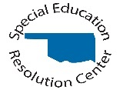
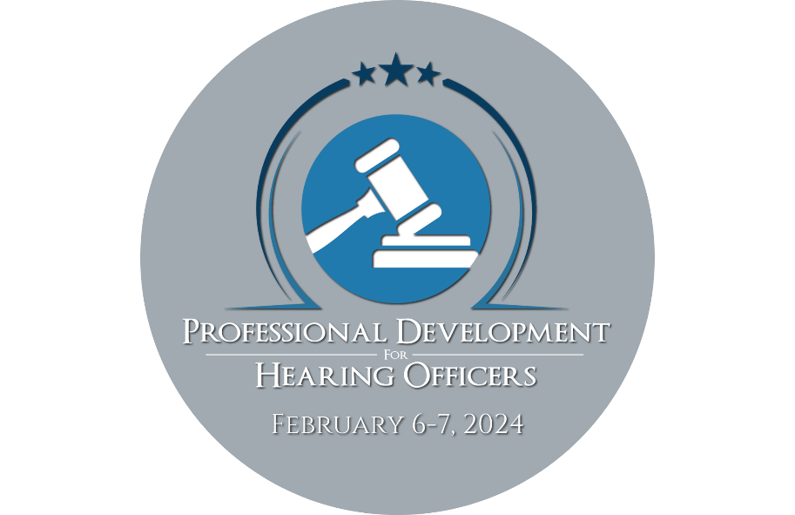

Virtual Event
February 6-7 ~ 11:00 a.m. - 4:15 p.m. CST
AGENDA & PRESENTER INFORMATION

Tuesday, February 6th
Welcome and Opening Remarks 11:00AM-11:15AM CST
Session 1: 11:15AM-12:45PM CST
Title: IDEA Caselaw Developments 2023-24
This program will discuss recent cases of interest for due process hearing officers and ALJs. The primary focus will be on decisions of the federal courts of appeals, but important state court and lower federal court cases will also be included. The program will take up the implications of the court decisions for due process hearing cases, and will seek to identify trends and emerging issues.
Presenter: Mark Weber has worked in the field of special education law for more than forty years. He is the author of four books: Special Education Law: Cases and Materials (previous editions with Mawdsley and Redfield), Special Education Law and Litigation Treatise, Understanding Disability Law, and Disability Harassment. He frequently speaks on disability law issues at national and international programs, and is active in community service and legislative initiatives. Before joining the DePaul University College of Law faculty in 1986, he worked as a staff attorney at the Legal Assistance Foundation of Chicago and as a clinical fellow and lecturer at the University of Chicago Law School. He was named Vincent de Paul Professor of Law in 2004. He is a graduate of Columbia University and Yale Law School

Session 2: 1:00PM-2:30PM CST
Title: The State Needs What?: Due Process Compliance Requirements for State Agencies under IDEA
Under the IDEA, each State Education Agency (SEA) and Lead Agency (LA) is required to oversee a compliant due process hearings system. As such, they must effectively and efficiently administer due process complaints and hearings by having written procedures that align with IDEA, oversee an infrastructure to support the case management, data collection, federal reporting requirements, and implementation of due process complaints and hearings, and maintaining a list of trained and impartial hearing officers that align practices and decisions with federal and State law. Coordination and collaboration with the independent hearing officers/administrative law judges to allow for proper oversight is critical to ensure an IDEA compliant system. The US Department of Education’s Office of Special Education Program (OSEP) monitors state agencies for compliance as part of their Differentiated Monitoring and Support (DMS) process. This session explores the necessary interactions between hearing programs and their state agencies.

Presenter: Claudette Rushing has worked as a special education hearing officer for the Vermont Agency of Education since 2019. She is also a new hearing officer for the state of Texas. She has worked in the field of education law and special education dispute resolution since 2011. Prior to her legal career, Ms. Rushing worked as a reading specialist, English as a Foreign Language (EFL) teacher, and as a general and special education teacher in Texas, France, and Maryland. She also worked extensively with gifted and talented children with Johns Hopkins University’s Center for Talented Youth. Ms. Rushing worked as a Legal Specialist and Dispute Resolution Coordinator for the Oregon Department of Education from 2011-2015. She worked as an attorney for the U.S. Department of Education’s Office for Civil Rights from 2015-2021. In addition to working as a hearing officer, Ms. Rushing also works with state agencies for IDEA mediation and investigation, through her consulting company, Education Resolutions, LLC., from coast to coast. She also serves as a mediator, complaint investigator, and hearing officer in several states and speaks to audiences across the nation on special education law and compliance.
Presenter: Melanie Reese joined CADRE as Director in October 2017. Prior to that, she was the Idaho Department of Education's Dispute Resolution Coordinator for Special Education since 2010. In that time, she helped grow Idaho’s facilitation program into a thriving and valuable option for Idaho’s districts and parents. Additionally, she oversaw the state's mediation, state complaint and due process hearing processes. In this role she worked closely with Idaho's Parent Training and Information Center and Local Educational Agencies to build relationships to serve children with disabilities. As professor emeritus (Boise State University, 2009), Melanie remains active in the academic community. The co-author of two successful textbooks (Personal Conflict Management: Theory and Practice and Mediation Theory and Practice), Melanie was a founding member of the Boise State University’s Dispute Resolution Graduate Advisory Board and is a member of Boise State graduate teaching faculty. Melanie served on the Executive Board of the Idaho Mediation Association, was a college ombudsman, and has been a professional mediator since 1990. She is regularly called to present on dispute resolution issues in special education, conflict management, alternative dispute resolution processes, and hot topics in special education. Additionally, Melanie has consulted for numerous organizations to improve their communication effectiveness.

Session 3: 2:45PM-3:45PM CST
Title: Digging Deep Into Data: Best Practices in Understanding a Psycho-Educational Evaluation
This presentation will focus on how different types of educational assessment data are used in the evaluation of eligibility for special education services, as well as monitoring progress on IEPs. The participants will examine different interpretations of data, including standard scores, grade equivalents, percentile ranks, and curriculum-based assessment scores. Additionally, participants will receive reference documents for which tests measure different components of comprehensive evaluations and considerations for determining if evaluations are comprehensive in nature.
Presenter: Dr. Sara Rich, a Licensed Health Service Psychologist and Nationally Certified School Psychologist, is a clinical assistant professor of OSU-Center for Health Sciences’ Department of Psychiatry and Behavioral Medicine. Dr. Rich also serves as Co-Director of the OSU BRIDGE Center. Dr. Rich has expertise in contextual implementation of MTSS across a variety of urban, suburban, and rural settings as a direct provider of services, trainer, and consultant. Currently, she serves as an evaluator for a federally funded Mental Health Service Professional Demonstration Grant and provides direct consultation to Oklahoma’s second largest school district on their initiative to implement MTSS. Dr. Rich also has extensive experience with special education services for students with and at-risk for disabilities. As a district level school psychologist, she facilitated the special education and pre-referral process at all her assigned sites. In her current role, Dr. Rich provides evaluations of children for social, emotional, behavioral, and academic concerns through the OSU Behavioral Medicine Clinic and works with families to navigate appropriate services for children within school and community settings.

Presenter: Dr. Brit'ny Stein is a Licensed Health Service Psychologist and Nationally Certified School Psychologist employed at the OSU-Center for Health Sciences' Behavioral Medicine Clinic. She also serves as Director of Technical Assistance for the OSU BRIDGE Center. Dr. Stein specializes in MTSS consultation and training, with implementation experience across rural, urban, and suburban schools. In her current role at the OSU Behavioral Medicine Clinic, she conducts neuropsychological evaluations to diagnose neurodevelopmental and mental health disorders in children and adolescents. She also currently serves on the evaluation team for the Oklahoma State Department of Education's Project AWARE grants, as well as a consultant to a large urban Oklahoma district on the implementation of whole-child MTSS. Prior to her role at OSU, she served as school psychologist at the Osage County Interlocal Cooperative for five years, supervising school psychology students in assessment, intervention, and consultation at the individual-, classroom-, and systems-level in rural schools, as well as participating on several multi-disciplinary teams to successfully write and implement a variety of state and federally-funded grants.

Wednesday, February 7th
Welcome and Opening Remarks 11:00AM-11:15AM CST
Session 4: 11:15AM-12:45PM CST
Title: (MDRs) Under IDEA: Modern Standards, Process, Data Bases, Expedited Hearings, Caselaw Examples
Not uncommonly, impartial hearing officers under IDEA will be called upon to hear cases challenging schools’ manifestation determination reviews (MDRs) and associated disciplinary placements. This session reviews the full gamut of the MDR requirement, from its origin to its modern iteration, to the details of performing the review, associated issues of FBAs and BIPs, special offenses situations, complications with additional diagnoses provided by parents, failures to implement IEPs, the expedited hearing process, entertaining challenges to local disciplinary findings, and pre-eligibility MDRs, among others. Caselaw examples will illustrate the nuances of hearing MDR challenges in real life.
Presenter: Jose Martin, J.D. For over 30 years, Jose Martín’s law practice has focused exclusively on matters involving the education of students with disabilities under the IDEA and Section 504. A graduate of the University of Texas School of Law, his background in journalism has led Jose to frequent publication in the area of disabilities laws and their impact on public schools. As a litigant, he has tried cases at the due process, district court, and court of appeals levels. As a speaker, Mr. Martín presents numerous sessions every year on disabilities laws to audiences at local, regional, state, online, and national conferences.

Session 5: 1:00PM-2:30PM CST
Title: When I get to Heaven: Ethical Issues for Special Ed Hearing Officers in the Real World
Two experienced hearing officers will share views on ethical issues submitted by participants.
Presenter: Jim Gerl is a Pennsylvania IDEA hearing Officer. Before that he was a special education law consultant and the author of the award-winning Special Education Law Blog. He was an IDEA mediator and a hearing officer for West Virginia for twenty-nine years, and has been a hearing officer for Utah, South Dakota, the U S Virgin Islands, Delaware, and he was an IDEA hearing officer and chief mediator for Washington, D.C. (2009 to 2011). He has also served as a state complaint investigator for New Mexico and South Dakota. Jim has spoken at numerous CADRE conferences and may other national, regional and state conferences and trainings. Jim has received a BA from the University of Illinois-Urbana with departmental distinction in political science; a master’s degree in public policy analysis from the University of Illinois-Chicago; and a law degree from the University of San Francisco.
Presenter: Ed Litteneker, J.D., upon retirement from the active practice of law, served as the Dispute Resolution Coordinator for the Idaho State Department of Education. Now in his second retirement, Ed serves as a special education hearing officer and complaint investigator for Idaho and Utah and does mediations and IEP Team facilitations in Idaho. In his law practice, he provided administrative hearing officer services for various Idaho State agencies, had an active mediation practice and taught Appropriate Dispute Resolution at the University of Idaho College of Law.

Session 6: 2:45PM-4:15PM CST
Title: Want to Take a Peek: Templates and Forms Used by Other States and Hearing Officers for Managing
Hearings and Writing Decisions!
Three different professionals share insight and forms that may assist you in your official capacities as hearing officials or managers of hearing systems. One, a former court clerk in the Northern District of Oklahoma prepared a template for HO decisions. Her template was created from the perspective of what a federal judge would expect to review if the matter came before his court. One, a former manager of a Due Process program will share templates and forms used by hearing officers in her state. And finally, one was a hearing officer, as well as a manager of programs in the Louisiana Department of Education. The insights presented might help fill in the blanks or provide alternatives for your current practice.
Presenter: Jo Anne Blades, J.D. was the Assistant Director of the Special Education Resolution Center for 18 years. SERC manages alternative dispute resolution and due process hearings through contract with the Oklahoma State Department of Education. She earned her Bachelor of Science Degree from Texas Tech University and Juris Doctor from The University of Akron. She was an educator in public schools for over 15 years, in private law practice for 10 years, and then the manager of SERC. During her years at SERC, she supported hearing officers and assisted them in carrying out their duties. She is a strong advocate for fair systems of dispute resolution for children with disabilities. One of her greatest joys was supporting her granddaughter in her journey as a neurodivergent individual. She retired at the end of 2023, but enjoys sharing information that might support other systems.
Presenter: Parris Taylor is an attorney working as part of the Louisiana Department of Education’s Executive Counsel Team, and the coordinator for the LDOE’s dispute resolution program for students with exceptionalities. Mr. Taylor was a former IDEA administrative law judge and deputy general counsel with the State of Louisiana’s Division of Administrative Law before joining the LDOE. Attorney Taylor started as a general practitioner with the Tyson, Pitcher, Avery, & Cunningham Law Firm before taking a position as a child support attorney with the State of Louisiana’s Department of Children and Family Services. He later transferred to DCFS to join its Bureau of General Counsel’s legal staff where he also worked as a child protection attorney with the Office of Child Welfare. Attorney Taylor served as founding chair, and co-chair, and is currently a member of the Louisiana State Bar Association’s Children’s Law Committee, and he is also a member of the LSBA’s Legal Services for Persons with Disabilities Committee. He was an invited speaker for special education workshops at the National IDEA Academy and the Lehigh University Special Education Law Symposium. Attorney Taylor has conducted continuing legal education seminars for the Louisiana State Legislature, the Louisiana State Bar Association, and he has been a featured presenter for community stakeholder groups and non-governmental organizations throughout Louisiana. He is a past member of the Louisiana State Legislature’s Child In Need of Care Task Force, a participant in the Louisiana Child Support Guideline Committee, and he was a past president of the Louisiana Association of Administrative Law Judges. Mr. Taylor graduated from Morgan State University in Baltimore. Later he attended and graduated from the Southern University Law Center in Baton Rouge, where he formerly served as an adjunct professor teaching administrative law, and is a long-standing member of Omega Psi Phi Fraternity, Inc.
Presenter: Denelda Richardson, J.D. earned her bachelor's degree from Southern Nazarene University in 1996 and her law degree from University of Tulsa College of Law in 2003, with Highest Honors, Order of the Curule Chair. She worked for the Hon. Sven Holmes, then Judge in the Northern District of Oklahoma, for 10 years. First as his paralegal, and then upon the completion of law school as a term clerk. She is also the mother of a son who is now 33 who has been deaf since birth. As a result, she understands the struggles in special education from both a personal and legal standpoint. She has been in private practice with the law firm of Rhodes, Hieronymus, Jones, Tucker and Gable since 2004.

