Suggested Resources from Dr. Sampson
Darlenesampson.com
Dsampso5@msudenver.edu

We are the RIGHT People at the RIGHT Time to CHANGE the WORLD!

CADRE 9th National Symposium/October 2022
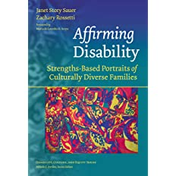
Podcasts
- Pod Save the People by McKesson on Spotify
- The Disability Visibility Podcast: https://disabilityvisibilityproject.com/
- The Element of Inclusion: https://elementofinclusion.com

The Social Construct of Race & Racialized Trauma
Addressing Anti-Blackness in Asian & Other Non-Black Communities of Color: https://centerforhealthprogress.org/blog/addressing-anti-blackness/
Reckoning With Anti-Blackness in Indian Country, Nick Martin: https://newrepublic.com/article/158294/reckoning-anti-blackness-indian-country
On Deconstructing & Unlearning Anti-Blackness in the Latinx Community, by Jennifer Mota,

Books Addressing Racial Trauma
Healing Racial Trauma: The Road to Resilience/Sheila Wise Rowe
The Racial Healing Handbook: Practical activities to help you challenge privilege, confront systemic racism, and engage in collective healing/Anneliese Singh
My Grandmother's Hands: Racialized Trauma and the Pathway to Mending Our Hearts and Bodies/Resmaa Menekem

Books (General DEI Topics)
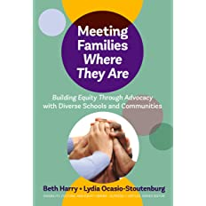

Dr. Sheldon Eakins/Leading for Equity
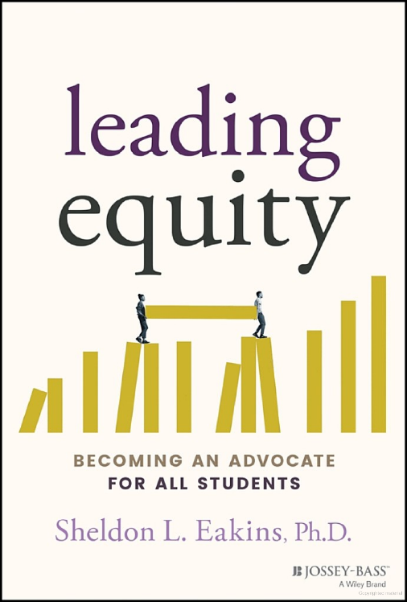

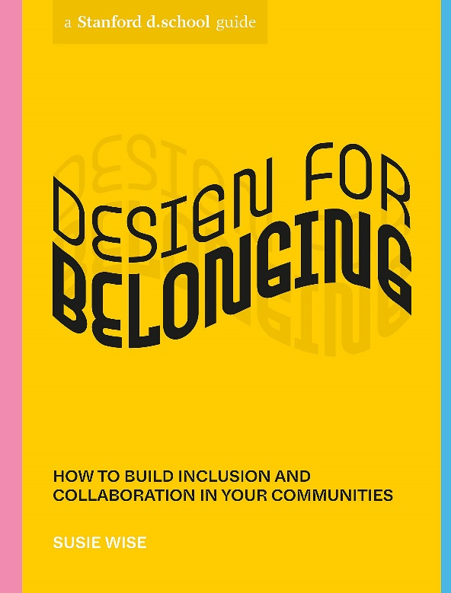
Excellent for School & Community Work!

Teaching to Transgress: Education as the Practice of Freedom/
Bell Hooks
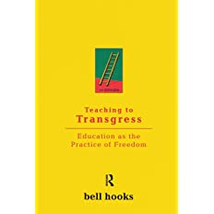

Activities
Building a Diversity Team
https://www.bildgta.ca/Assets/misc/DEI%20handbook.pdf

Diversity Activities
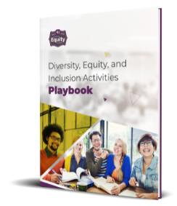

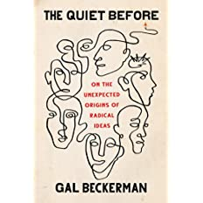
Conscious Thoughts & Specific
Behaviors that Can Change the World

Online Virtual Courses from the Western Educational Equity Assistance Center (Free)
WEEAC Virtual Events and Electronic Content
Dr. Sampson works
here as a diversity specialist. We provide consultation & support
To K-12 Schools in the Western Region
at no cost to schools.
https://www.msudenver.edu/western-educational-equity-assistance-center/

Budgeting for Educational Equity
https://www.wested.org/wested_podcast/budgeting-for-educational-equity/

Dispute Resolution
African American Culture & Dispute Resolution
African American Culture and Alternative Dispute Resolution - Race, Racism and the Law

Mediation Questions through the lens of Equity
https://youtu.be/ZEE4_nFYhmY

ONWARD WITH HOPE & EQUITY!

